Presenter Bios

 What makes Scott Barbarino one of the most sought-after experts in the field of cabaret and piano bars? Longevity, experience, and the savvy to apply that rich background to the present realities of the entertainment world. Scott has been immersed in the cabaret business for over forty years––as a club manager, booker, producer, promoter, and performer, entrepreneur, industry consultant, and publisher of the acclaimed NiteLifeExchange.com web-based magazine, “Where Broadway and Cabaret Meet,” as well as Producer of the award-winning internet show PianoBarLive! In 2002, Scott joined the management team at Ellen’s Stardust Diner on Broadway, where he continues as Artistic Director, mentoring the singing waitstaff, The World Famous Stardusters, among other responsibilities. In association with the Iridium, downstairs at Ellen’s, he has produced New Faces of Broadway to showcase the Stardusters’ talent. Among the many other shows, Scott has produced at the Iridium are an open mic night called The Follow Spot, tribute shows to cabaret legend, Julie Wilson and songwriter Ervin Drake, and the 100-show run of Terese Genecco and her Little Big Band. During much of these early successful ventures in the business of cabaret, Scott was also performing as the founder and lead singer of Scott Barbarino & The Bev-Naps, a retro vocal comedy a cappella doo-wop group that won two MAC Awards (1999––Vocal Group and 2000––Musical Comedy Group).

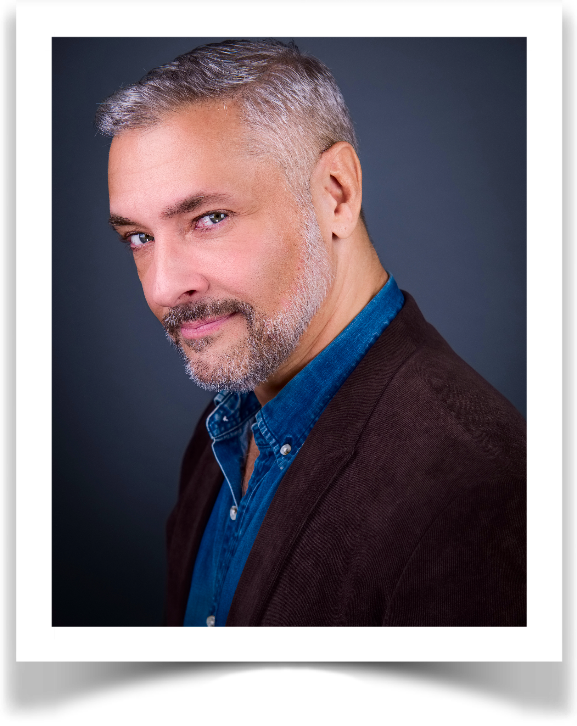MAC and Bistro Award Winner James Beaman’s most recent directing projects include: the 2025 MAC Award-nominated Best Tribute Show, What a Man! Goldie Dver Sings Anthony Newley (which just had its London debut at The Crazy Coqs); Richard Skipper Celebrates “Hello, Dolly!” and Everything You Always Wanted To Know About Richard Skipper (But Were Afraid To Ask); Jo Walker and Vayle’s Two For the Road; and Dan and Chrissy Pardo’s debut cabaret, Dreams Don’t Come True in Pennsylvania, which returns to Chelsea Table and Stage in October. Other upcoming projects include Vayle’s solo cabaret debut show, Love Is On Our Side, Alex De Suze’s Nina&Sarah&Aretha&Alex, and Goldie Dver’s Dorothy Fields Songbook show, The Rhythm of Life. Jamie is resident director for Sneak Peek, Goldie Dver’s series showcasing the best of NYC cabaret, now in its second season at Don’t Tell Mama.

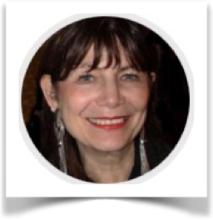Alix Cohen is the recipient of ten New York Press Club Awards. Her writing history began with poetry, segued into lyrics and took a commercial detour while holding executive positions in product development and design. A cultural sponge, she now turns her diverse personal and professional background to authoring pieces about culture/the arts with particular interest in artists/performers. She’s a voting member of Drama Desk and lives in Manhattan. Of course.

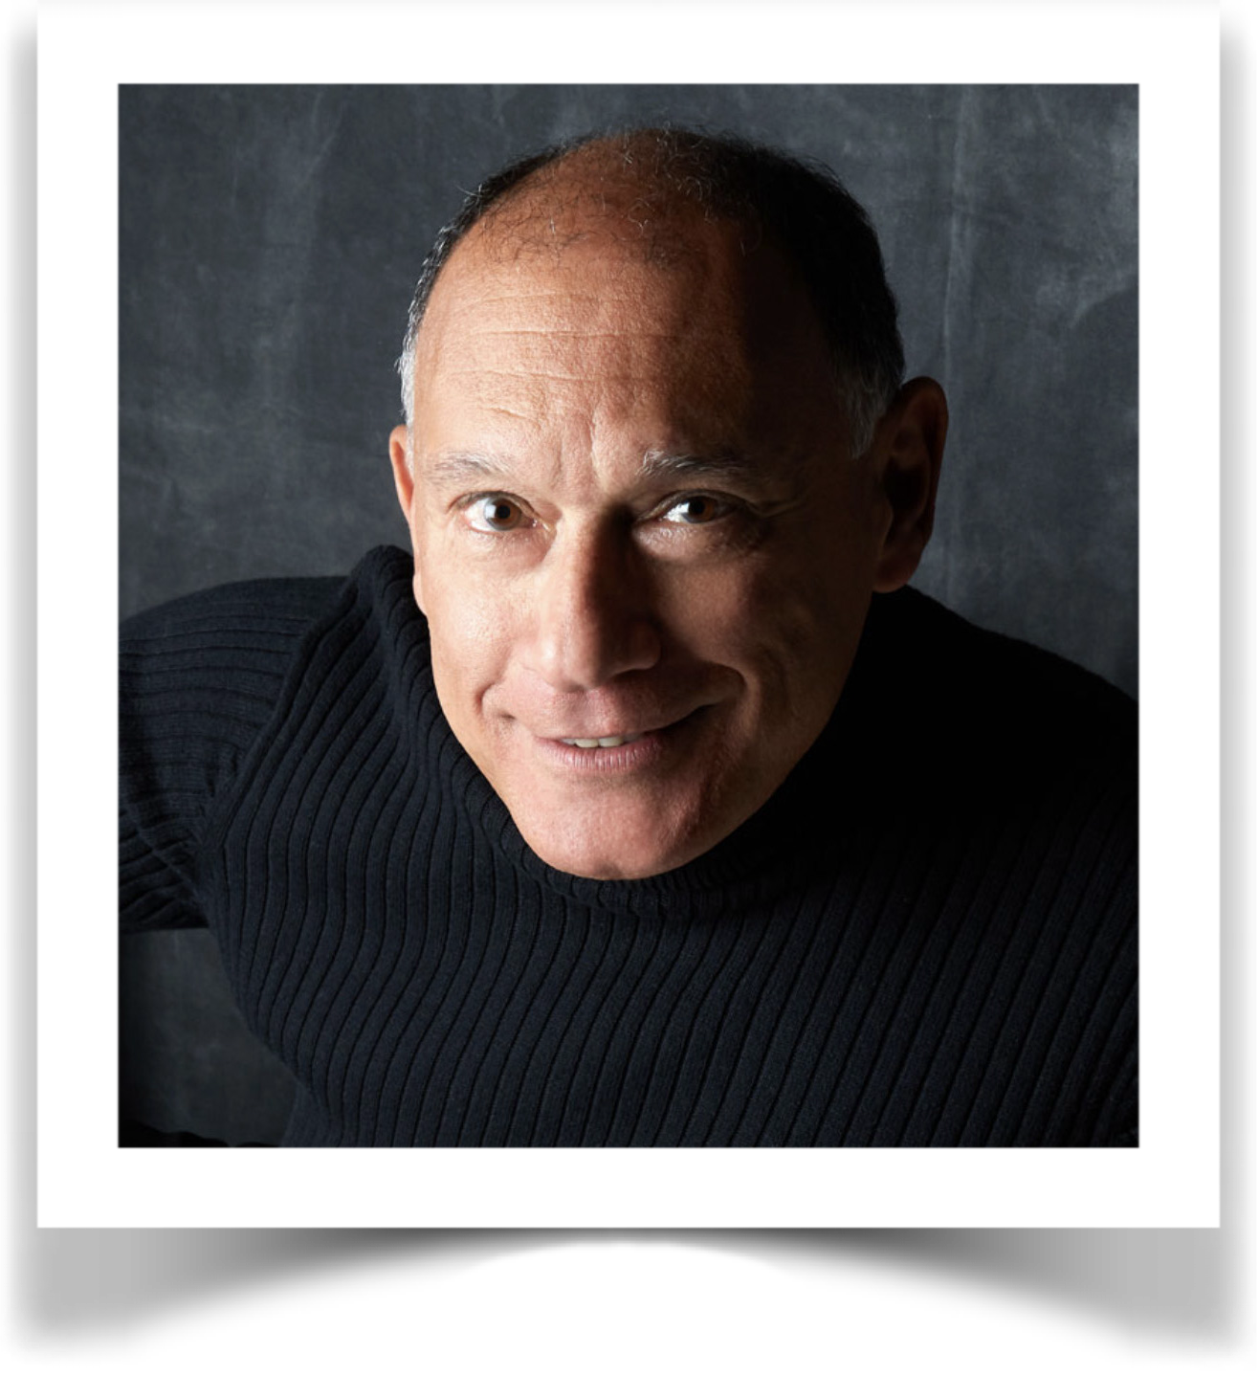Frank Dain is a vocalist, graphic designer and, since 2003, the Editor-in-Chief of Cabaret Scenes, the only print publication dedicated to cabaret.

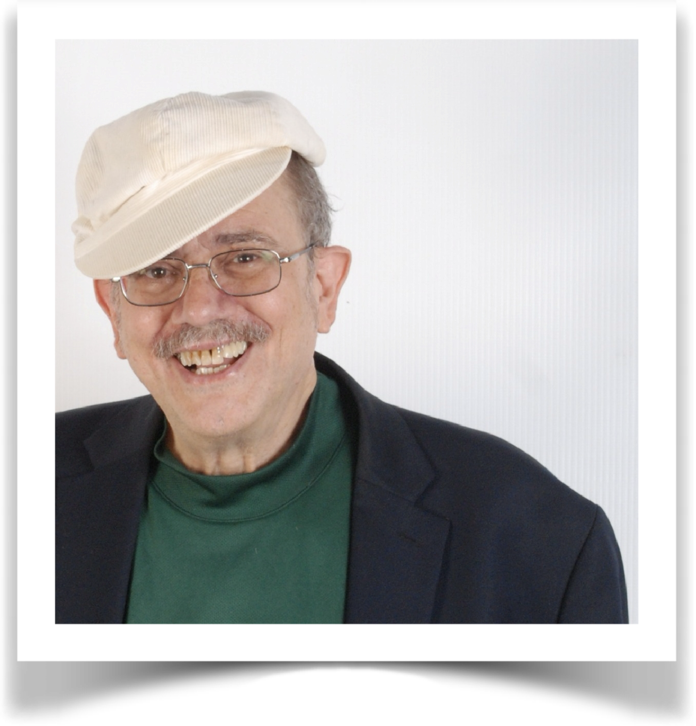Chip Deffaa has written or co-written nine published books, 20 plays, and one motion picture. He’s produced or co-produced 47 albums, the most recent including: “Irving Berlin: Love Songs and Such,” “The George M. Cohan Songbook,” and “Chip Deffaa’s Tin Pan Alley.” He's produced more recordings of the songs of Irving Berlin and George M. Cohan than any other living producer. And he's recorded more cabaret artists than any other producer. For 18 years he covered entertainment--including jazz, cabaret, and theater--for the New York Post. In his youth, he studied at the American Academy of Dramatic Arts. He is a graduate of Princeton University and a trustee of the Princeton “Tiger” magazine. He wrote and directed such Off-Broadway successes as “George M. Cohan Tonight!” and “One Night with Fanny Brice.” His shows have been performed everywhere from London to Edinburgh, to Seoul. He is a member of the Dramatists Guild, MAC, ASCAP, the Stage Directors & Choreographers Society, and NARAS. He’s won the ASCAP/Deems Taylor Award, the IRNE Award, and a New Jersey Press Association Award.

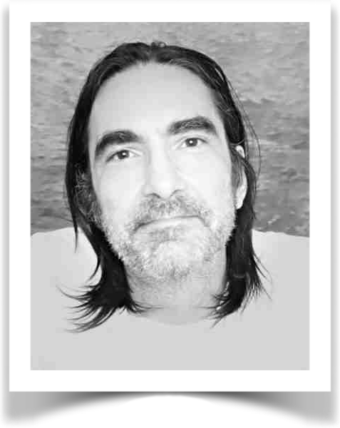Jason Ellis has directed over 25 shows for cabaret and small theaters. Some favorites for cabaret include Cabaret Anarchy, Too Many Ballads, Paper Dolls, Merry Christmasish, Ukulele Island, The Ev Sullivan Show, and Penzance-Ish.

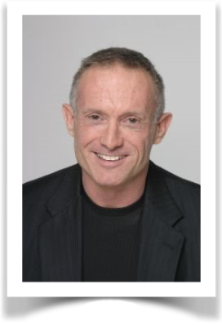Pianist James Followell has worked and toured as a musical director, accompanist, and arranger with many luminaries of Broadway and cabaret, including Sharon McNight, Kristen Chenoweth, Lee Roy Reams, KT Sullivan, Jeff Harnar, Jennifer Sheehan, Tom Andersen, Karen Mason, and currently with Tim Connell. Working with Jerry Herman, James provided the vocal & piano arrangements for the musical revue, Showtune, celebrating the words and music of Jerry Herman, which is in Mr. Herman's library of musical shows. Theater credits as conductor/pianist include: Little Shop of Horrors (Stockholm and Hamburg), Forever Plaid (Original Off-Bway cast and 1st National Tour), The Best of Times (Vaudeville Theater, West End). James resides in Manhattan, and has received the Dick Gallagher Award from the Mabel Mercer Foundation for outstanding work as a cabaret musical accompanist and was the pianist and arranger for the 92nd Street Y's Lyrics & Lyricist's tribute to Ms. Mercer.

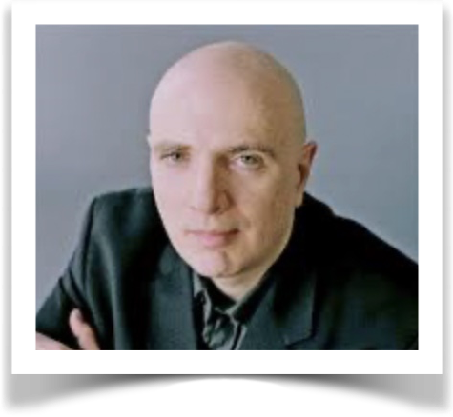Will Friedwald has written about music for The Wall Street Journal and was the jazz (and cabaret) critic for the New York Sun. He is the author of nine books, including A Biographical Guide to the Great Jazz and Pop Singers; Stardust Melodies: The Biography of Twelve of America’s Most Popular Songs; Jazz Singing: America’s Great Voices from Bessie Smith to Bebop and Beyond; Sinatra! The Song Is You; and Tony Bennett: The Good Life (with Tony Bennett). He has written liner notes for nearly five hundred compact discs, for which he has received eight Grammy nominations. He has also written for Vanity Fair, The Village Voice, Entertainment Weekly, American Heritage, and The New York Times, among others publications.

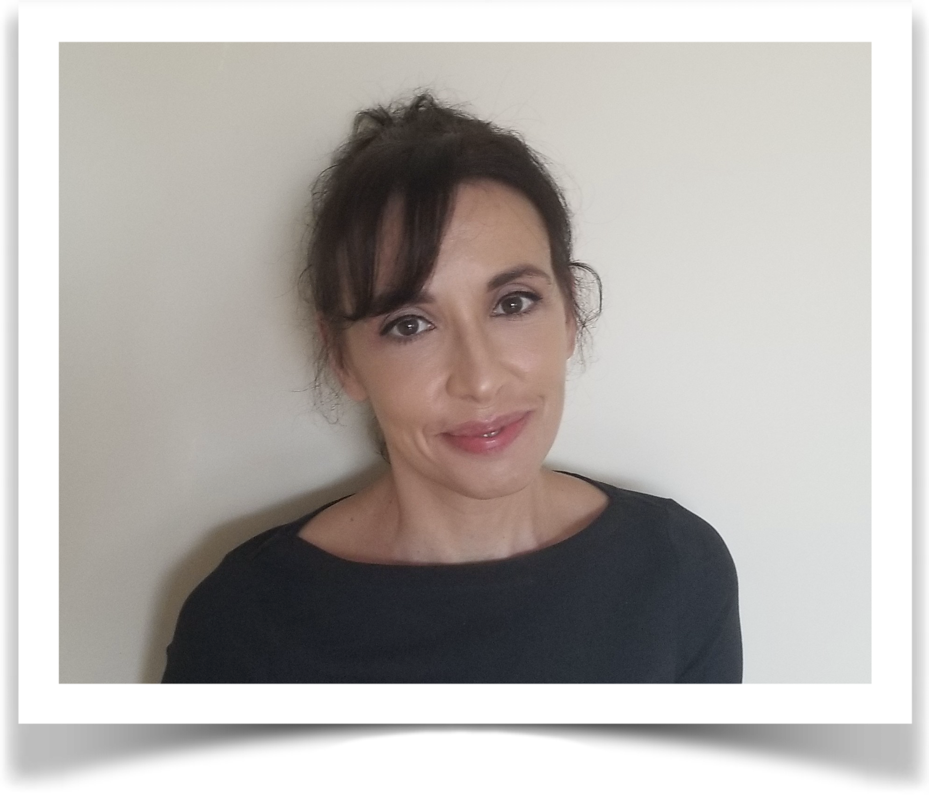Elysa Gardner is a contributor to the New York Times, focusing on cabaret. She's also a theater critic for the New York Sun and has written about music and theater for the Los Angeles Times, The New Yorker, The Village Voice, Time Out New York, Town and Country, Rolling Stone, and various other publications.

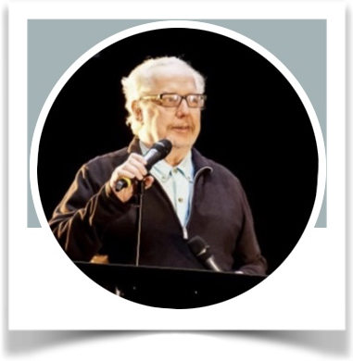Gerry Geddes, critic for BistroAwards.com, is an award-winning director, writer, teacher, performer, lyricist, and a contributor to the podcast Troubadours and Raconteurs. He conceived and directed the acclaimed musical revues Monday in the Dark with George (Bistro and MAC Award winner), Put on Your Saturday Suit—Words & Music by Jimmy Webb, and Gerry Geddes & Company (in its five-year residency at Pangea). He has directed singers André De Shields, Darius de Haas, Helen Baldassare, and Lisa Viggiano. He has been active in the cabaret world for over five decades and has produced numerous CDs; his lyrics have been performed and recorded here and in Europe. Gerry’s workshop, The Art of Vocal Performance, is regularly offered to singers of all levels. His memoir of life in NYC, Didn’t I Ever Tell You This?, was recently published and is available at barnesandnoble.com. He is currently at work on his first novel.

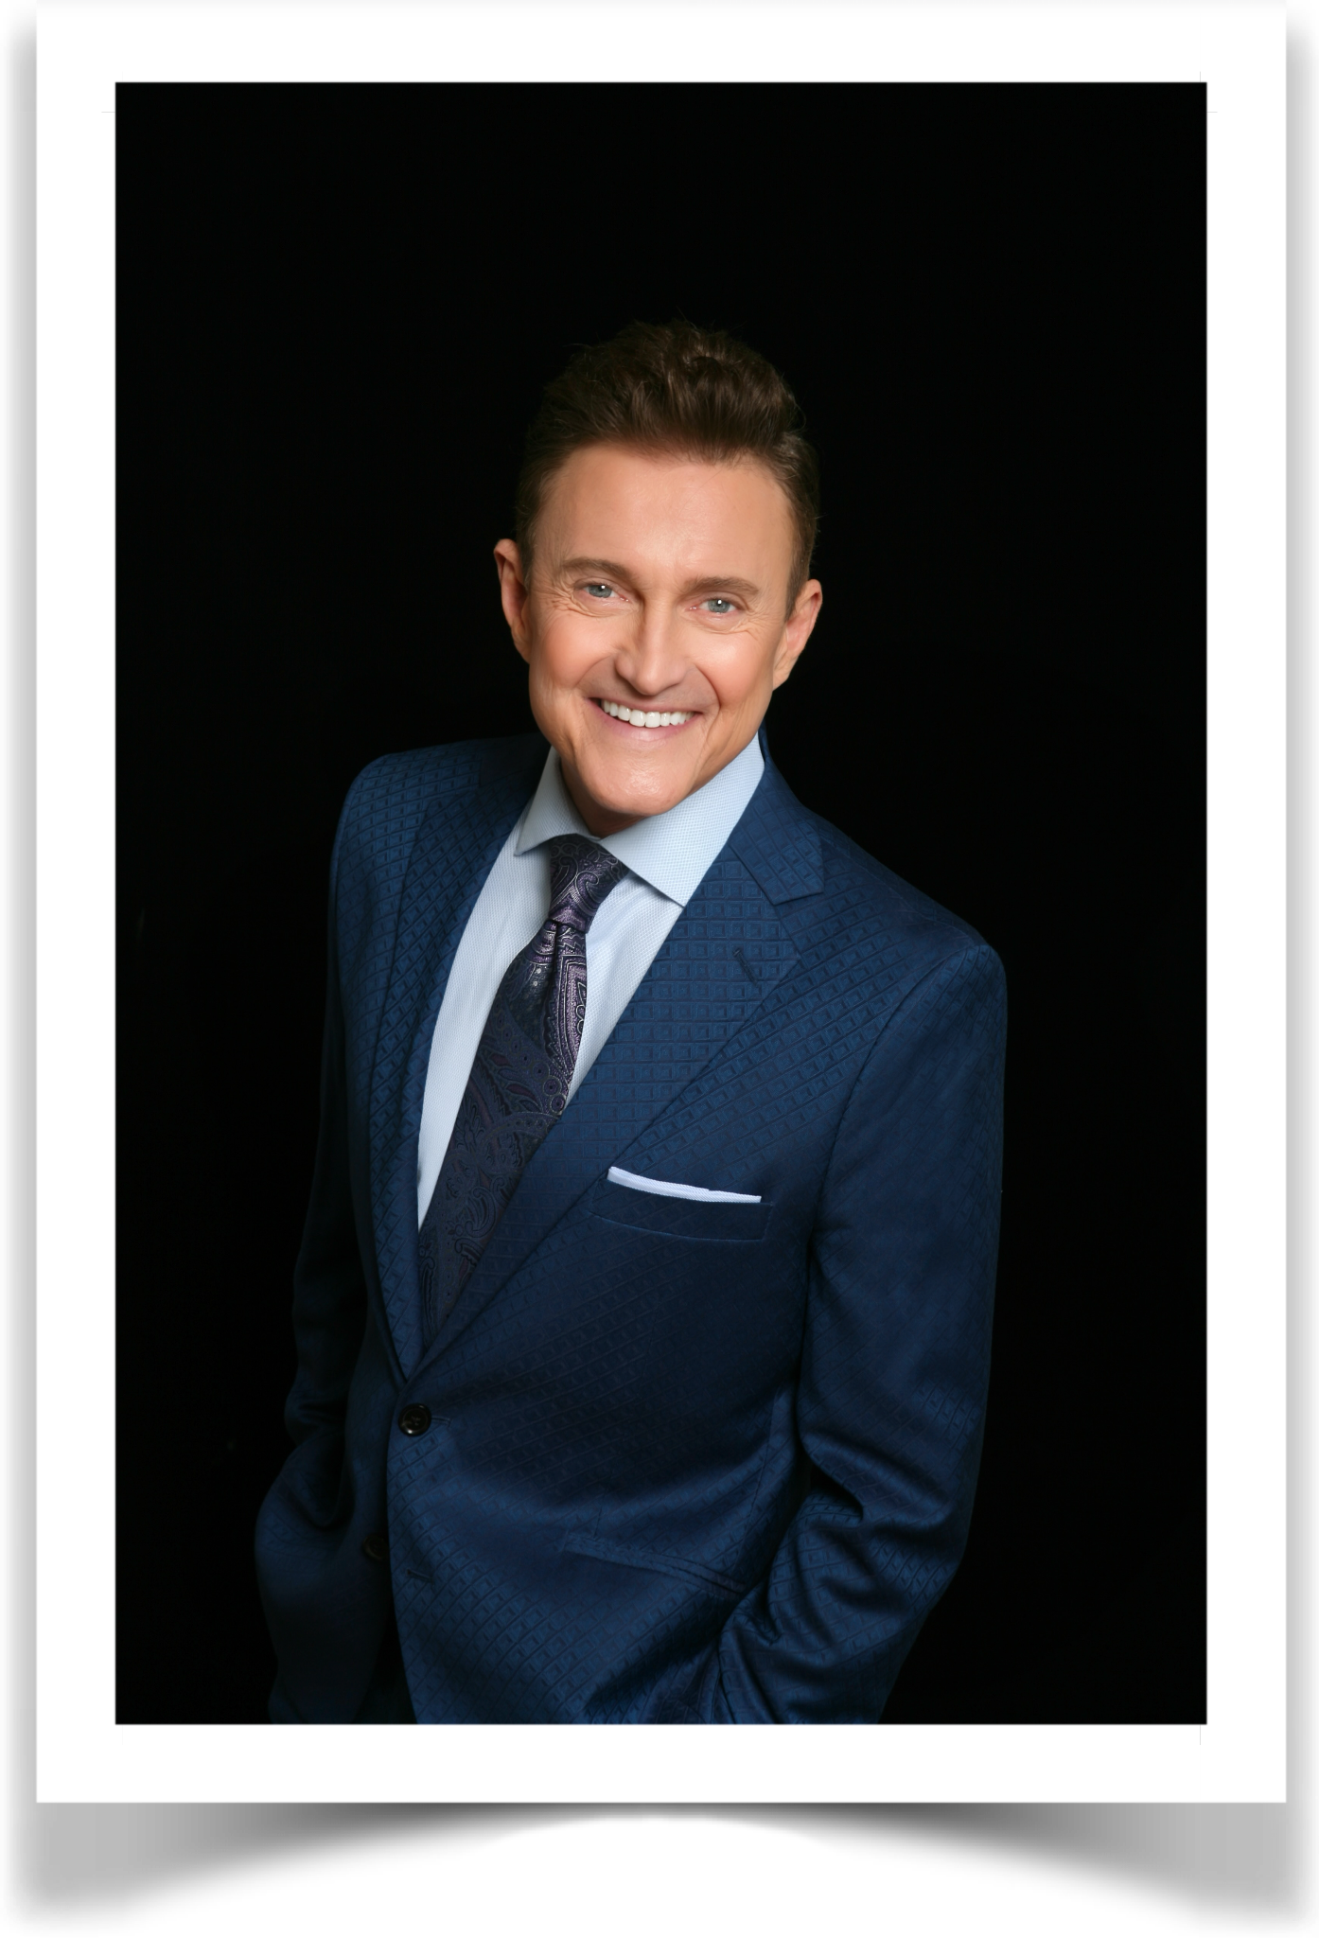Jeff Harnar is a Manhattan-based multi-award-winning cabaret, concert, and recording artist. His Carnegie Hall appearances include both the Cole Porter and Noel Coward Centennial Galas. His PBS-televised concerts include The 1959 Broadway Songbook with Alex Rybeck, and both American Songbook: Stephen Sondheim and Remember: Songs of the Holidays with KT Sullivan. His most recent albums are JEFF HARNAR sings SAMMY CAHN The Second Time Around (2024), A COLLECTIVE CY (2023) and I KNOW THINGS NOW: My Life in Sondheim’s Words (2022), all from PS Classics. He is the winner of multiple Broadway World, Manhattan Association of Cabaret, and Bistro Awards, The Noel Coward Foundation Cabaret Award, The Mabel Mercer Award; and Jeff was the 2022 Chicago Cabaret Professionals National Honoree. Jeff is also a multiple award-winning director. Please visit www.jeffharnar.com.

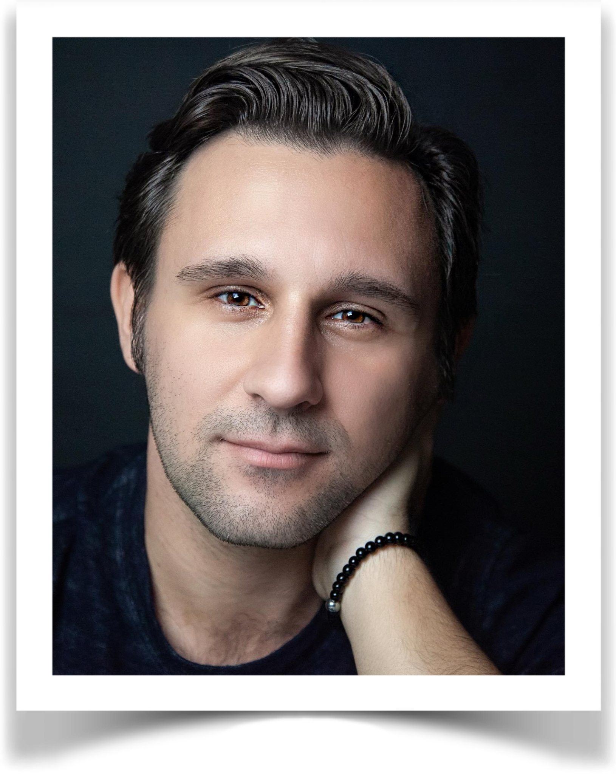Nicolas King Broadway: Beauty & The Beast, A Thousand Clowns with Tom Selleck, Carol Burnett's Hollywood Arms directed by Hal Prince. Regional: Follies, The Wizard Of Oz. TV: The Marvelous Mrs. Maisel, appearances on The View, Today, Sally Jesse Raphael, twice on The Tonight Show with Jay Leno, Kenny The Shark, 8 consecutive years on Jerry Lewis MDA Telethon in Las Vegas, and numerous national TV commercials, including award-winning “Oscar Mayer Lunchables.” Winner of 2025 MAC Award for Best Major Male Vocalist, 1995 and 1996 Talent America Award, 2010 Julie Wilson Award, 2015 AMG Award Artist of the Year, 2012 Bistro Award “Outstanding Performer of the Year,” 2019 Legends Award, and 2020 BroadwayWorld Award for Best Swing Act. Appearances include Carnegie Hall, Lincoln Center, Ronnie Scott’s, Birdland, 54 Below, Chicago Shakespeare Theatre. Nicolas has performed and collaborated with Neil Simon, Tony Danza, Linda Lavin, Jane Monheit, Norm Lewis, Debby Boone, Billy Paul, Jennifer Holliday, and toured the country for over 10 years as opening act for his mentor, Liza Minnelli. His latest album, Act One, is available everywhere.

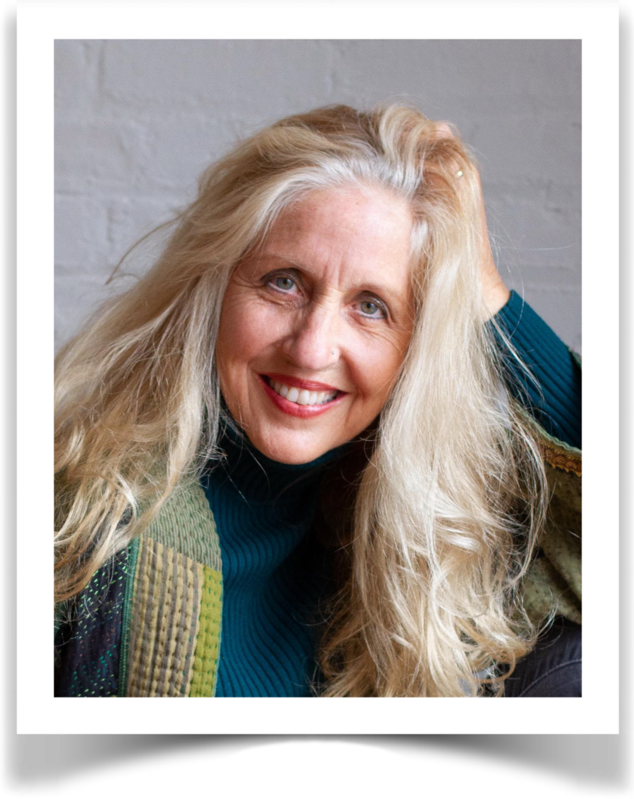Singer-actress Karen Kohler lives unconventionally in art and love. She emigrated to the U.S. from Germany as a child, learned English in a gospel choir, married her college sweetheart and was stockpiling options in a plum corporate gig when the call to performance seized her. For decades she has stewarded a critically acclaimed international singing career based in New York City, presenting rare story songs crossbred in seven languages and a decadent range of theatrical and musical styles from jazz and Delta blues to classical, rock-folk and cabaret. “It is Ms. Kohler’s exquisite taste in songs and her band’s ability to play them in any style that leaves you open-mouthed with admiration,” says Stephen Holden in The New York Times. Winner of the NY Nightlife, Mac, and BroadwayWorld awards, Kohler is the founding producer of the Backstage Bistro award-winning ensemble, Kabarett Kollektif, and the international cabaret festival, Kabarett Fête. In 2007, she endowed the world's first collegiate scholarship in the cabaret arts at Long Island University. As a director, she lectures at the university level on the European roots of small stage performance art and guides a diversity of artists in fulfilling their creative calling. www.karenkohler.com

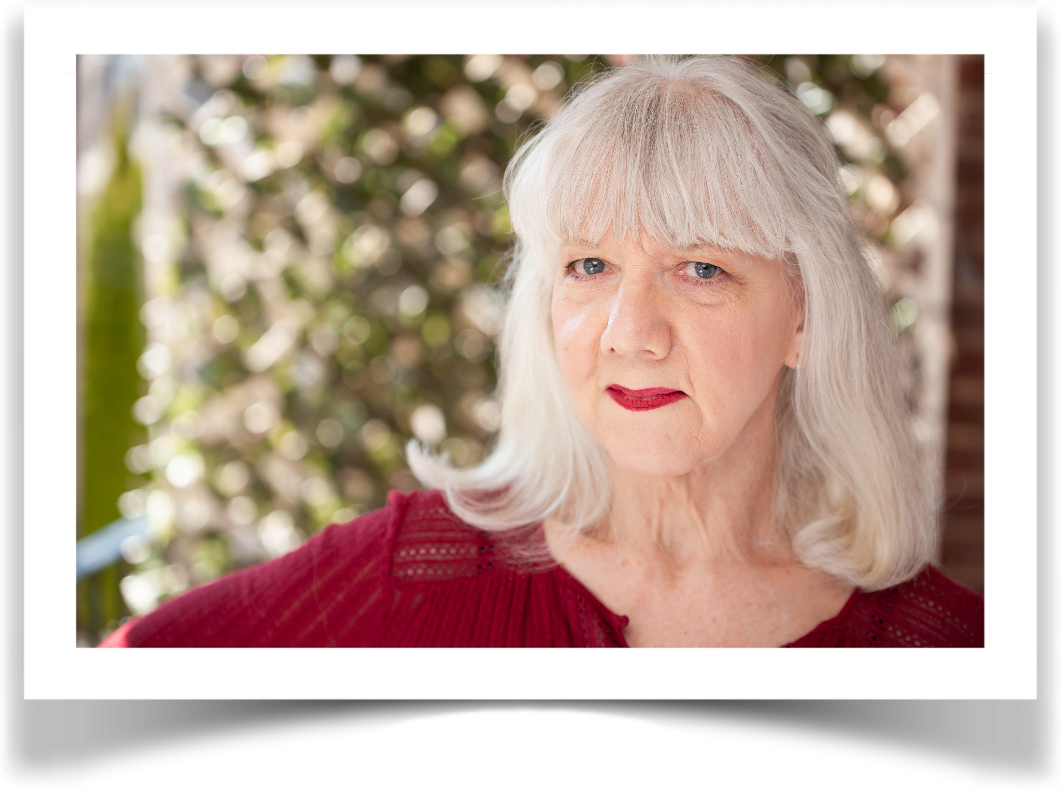Mary Lahti was a late bloomer, taking her first tap dance class when she was 18. That led to her first musical, Anything Goes. The title alone became her motivation into various dance groups, choreography, theater, film, voice and cabaret. Mary has led various dance and movement workshops and enjoys helping to motivate people to move. Mary is a current member of the senior dance team, The Pacemakers, and is a 2014 and 2023 MAC Award winner (Debut Show for A Kid Again; Special Production, Woulda ~ Coulda ~ Shoulda). www.marylahti.com

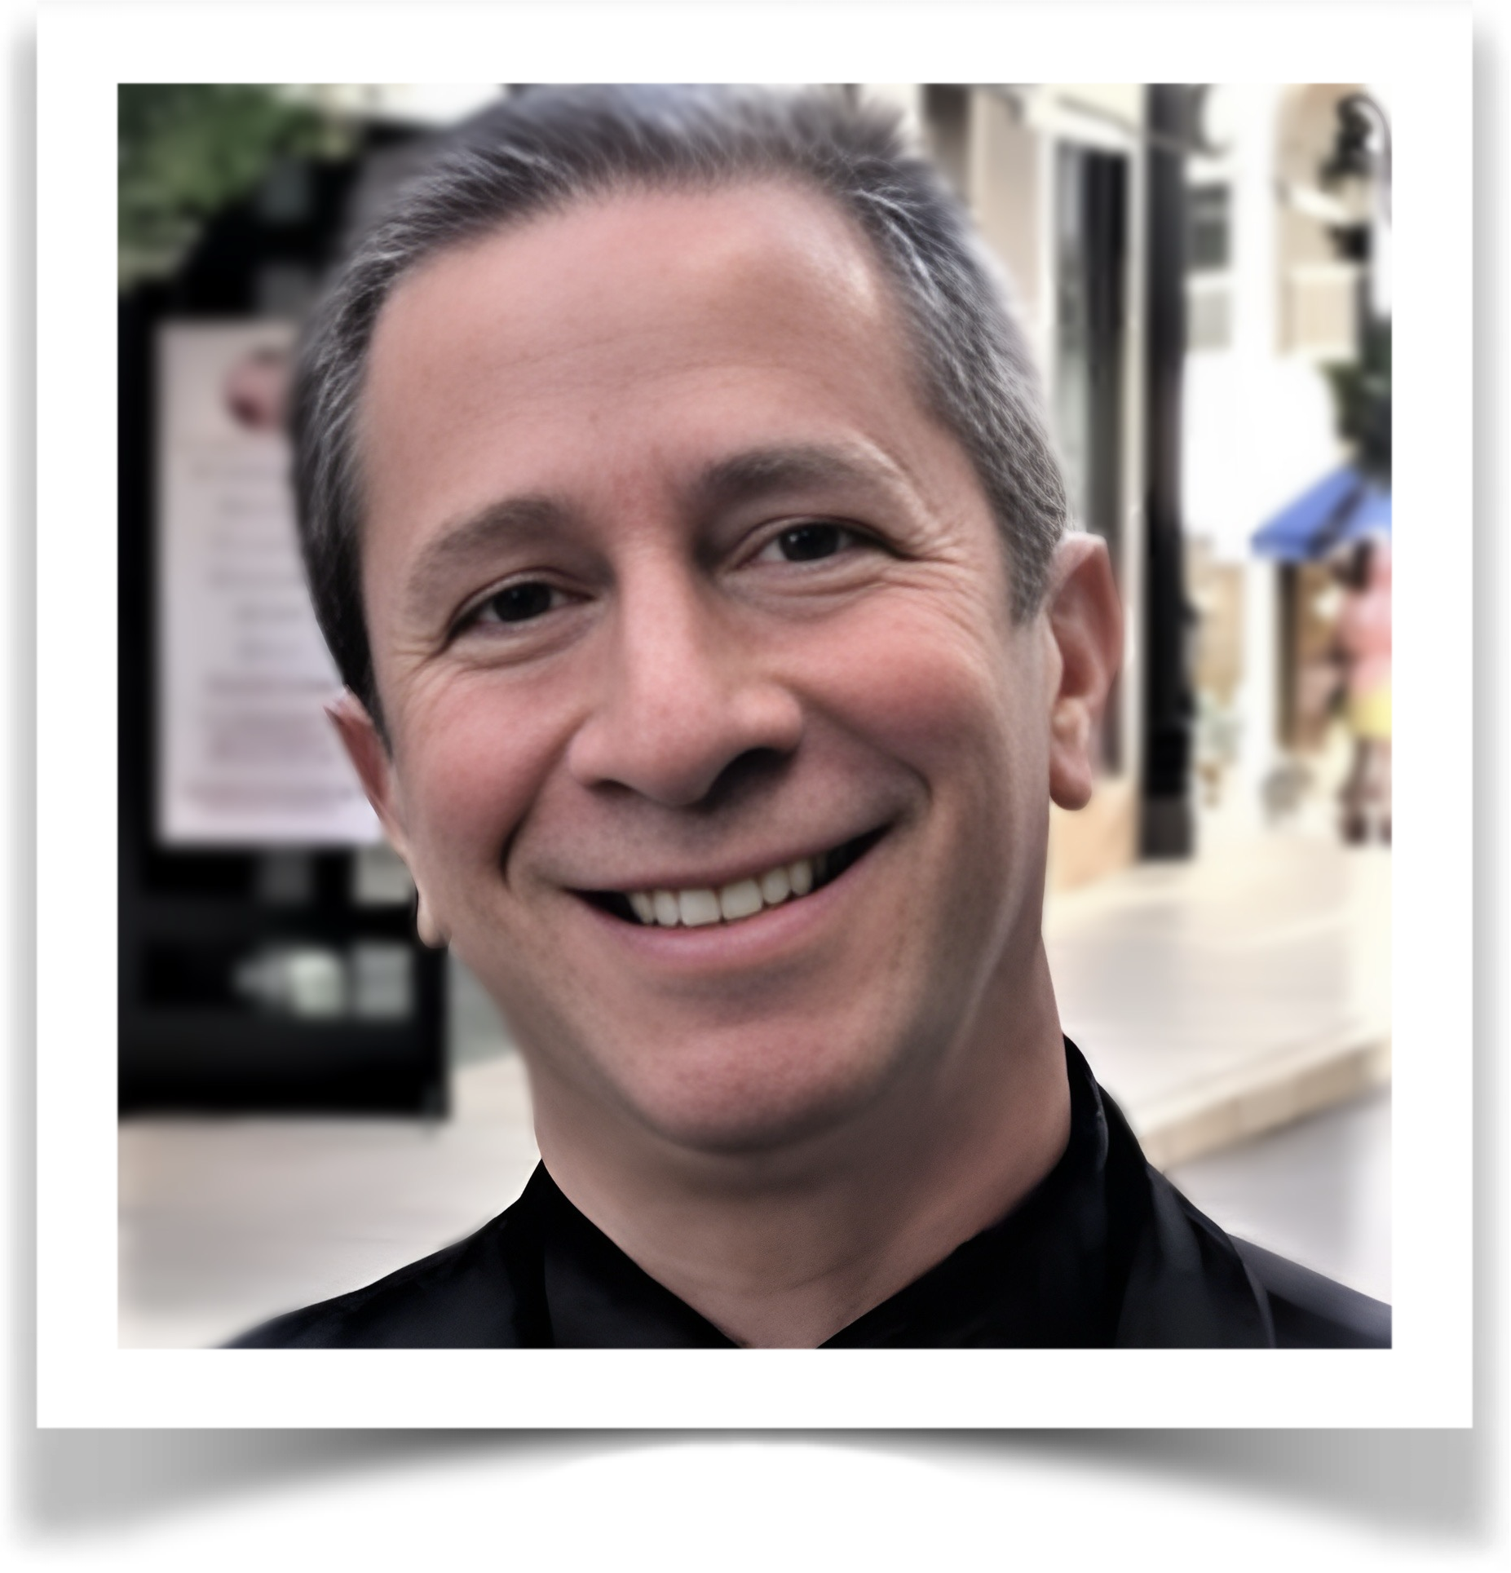Michael Lavine has worked as a musical director, pianist, vocal coach and singer all over the world. He musically directed a concert of the works of Stephen Schwartz, featuring Stephen himself, Ben Vereen, Paul Shaffer, Alice Ripley, Daisy Eagan, Constantine Maroulis, Bryan Batt, and more, and produced and musically directed Rediscovered Hamlisch, a CD of previously unrecorded songs by Marvin Hamlisch, featuring Kelli O’Hara and other Broadway stars. Michael conducted The Little Mermaid at Lyric Theatre of Oklahoma, starring Emily Skinner, musical directed Comden & Green’s Billion Dollar Baby at Off-Broadway’s York Theatre, starring Kristin Chenoweth, Marc Kudisch and Debbie Gravitte, as well as Burton Lane’s Carmelina (also at the York). He has shared the stage with Mimi Hines and Peter Howard (his mentor) in This Funny World (a Rodgers and Hart revue) at the Kennedy Center. Michael also regularly plays for the Outer Critic's Circle Awards in New York, and has conducted orchestras in a number of cities around the country. A graduate of Columbia University, Michael owns one of the larger privately held sheet music collections in the world. In addition, Michael gives master classes on the performance of songs and auditioning in New York, Los Angeles, Moscow, Switzerland, Bangkok, Australia, Singapore, Manila, Martha's Vineyard, and other locations. More details can be found at Michael's website, www.michaellavine.net. He can be reached at Broadwaymhl@aol.com.

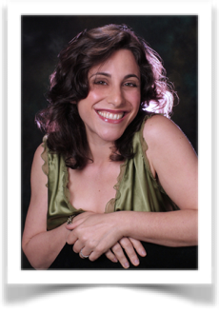Jennie Litt is a cabaret performer, director, performance coach, lyricist, playwright, fiction writer, and audiobook narrator based in NYC. She performs and writes with her husband, pianist-composer David Alpher. Together they have recorded two CDs of original cabaret songs, Two Apples (2014) and Songs For Sapiosexuals (2019) (available to stream on Spotify, Apple Music, and Amazon Music), and are developing a musical, The Mitfords At War, based on the lives of the notorious Mitford sisters, British aristocrats who used their beauty, wit, intelligence, and connections to become intimate with the men who power-brokered World War II. With David Alpher, she created the Cabaret Performance Workshop at SummerKeys in Lubec, Maine, now in its eleventh year; they also co-direct an annual student cabaret at Vassar College, in addition to working with private clients in NYC and beyond. Their latest show, Relatively Speaking Singing!, in collaboration with their daughter Mirabelle, just completed a run at Don’t Tell Mama. Jennie is a longtime member of MAC’s Board of Directors, and the producer of MAC To School.

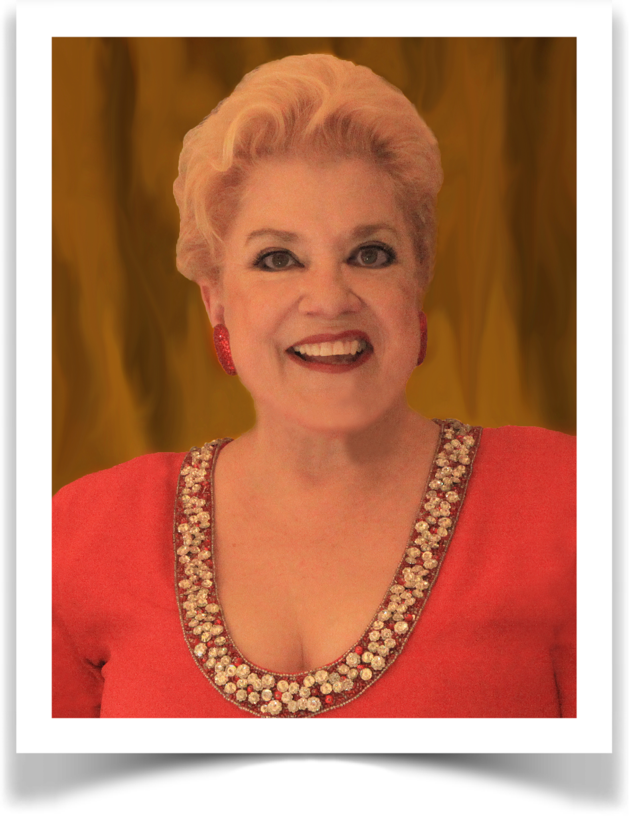Sharon McNight began her career in San Francisco, and made her Broadway debut in 1989 in Starmites, creating the role of Diva. She received a Tony nomination as Best Leading Actress in a Musical for her performance, and is the recipient of the coveted Theatre World Award for Outstanding Broadway Debut and a Hirschfeld drawing of her character. She has six solo recordings to her credit, and has played from Moose Hall to Carnegie Hall, from Los Angeles to Berlin. She has won two Lifetime Achievement awards, a MAC Award, a Bistro award, a New York Nightlife award, and six San Francisco Cabaret Gold awards. Her eclectic repertory ranges from blues to country to good old-fashioned entertainment. She can make audiences laugh and cry at the same show with her eclectic bag of musical choices. The Los Angeles Times called her "one of the great wonders of the musical stage." She is most noted for her movie reenactment of The Wizard of Oz and for being one of the few real women to impersonate Bette Davis. Ms. McNight received her Masters of Arts degree in Direction from San Francisco State College and was a master teacher on the faculty of the Cabaret Conference at Yale University. She says the greatest day of her life was the day she quit smoking.

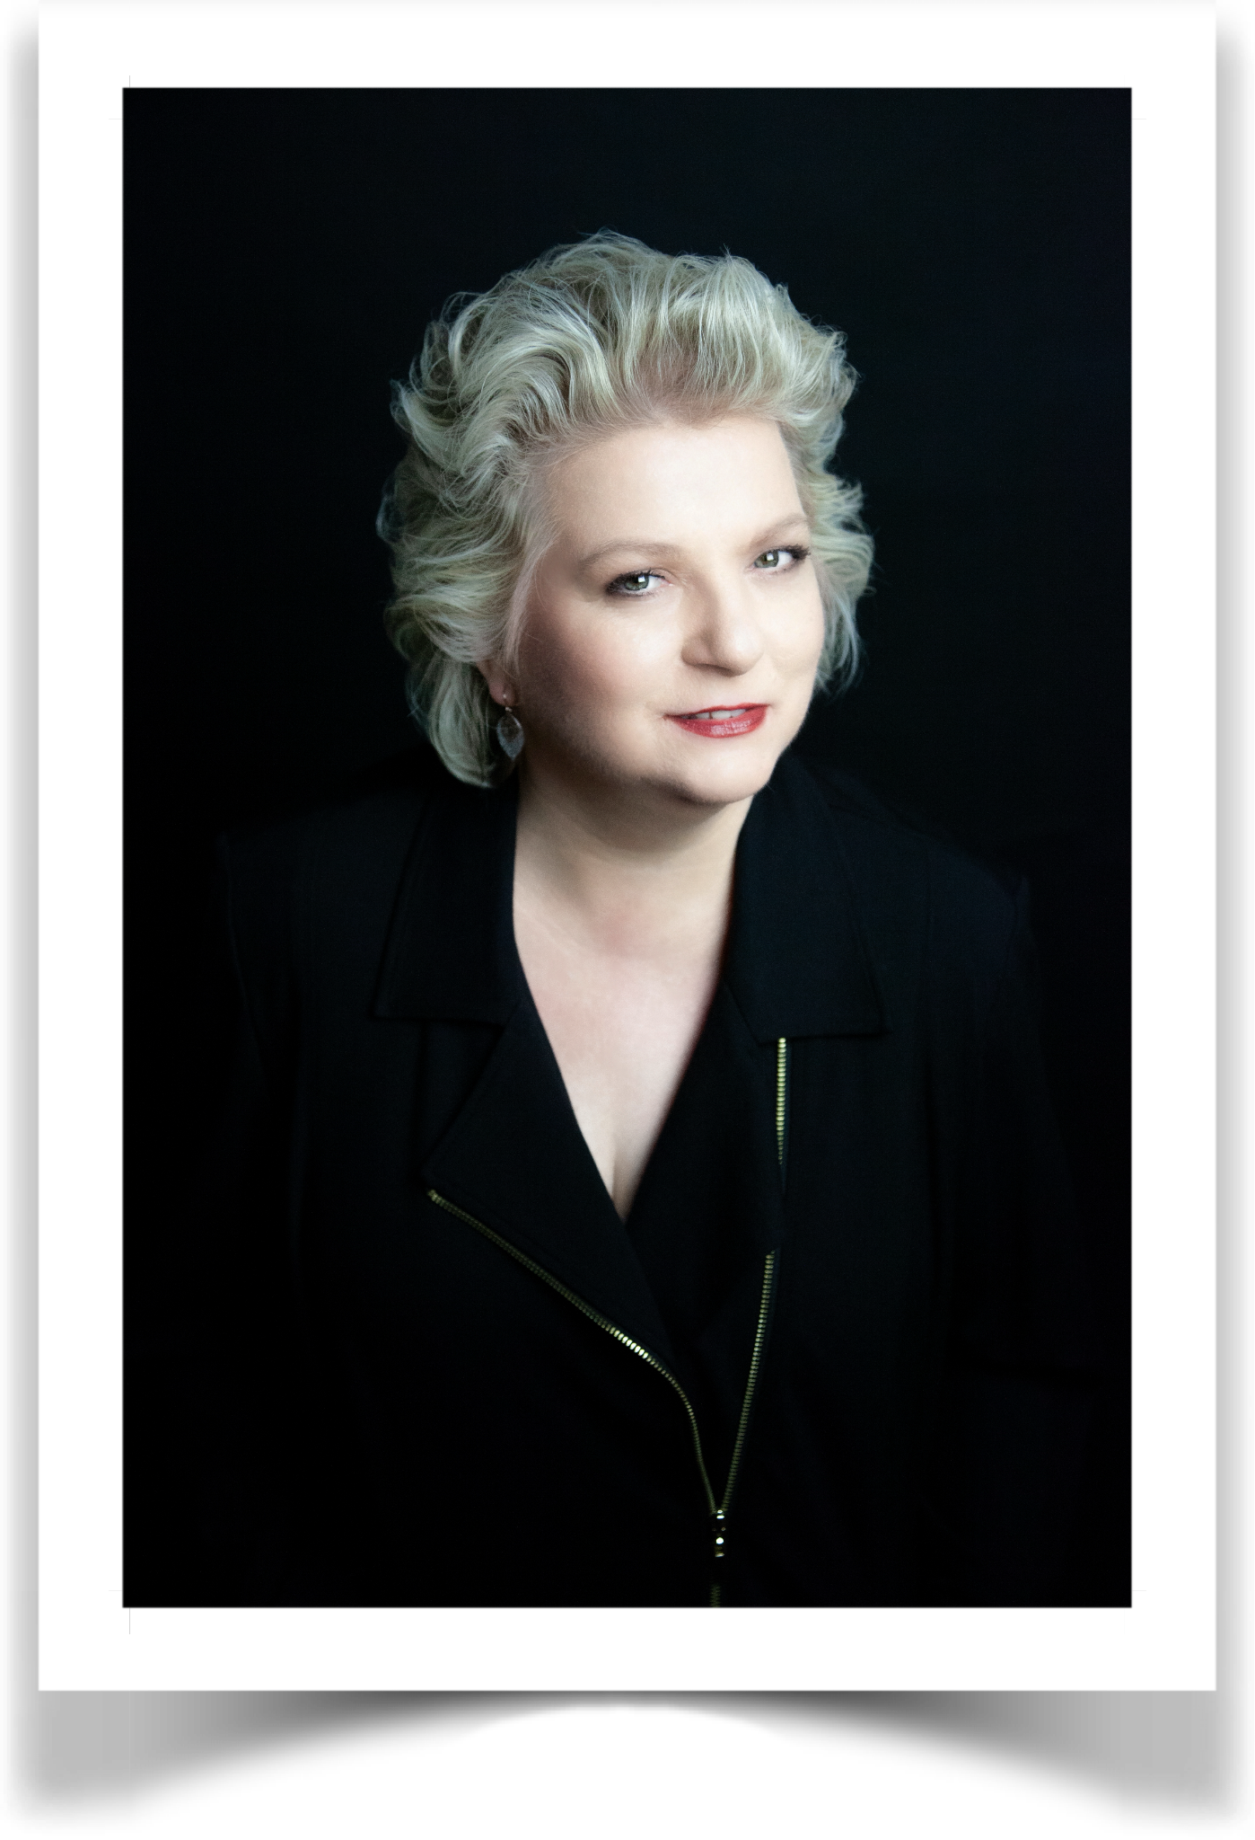Tanya Moberly first performed at Don’t Tell Mama in 1998 in The Blonde Leading The Blonde. Twenty-seven years later, she is the 2025 MAC Award Winner for Major Female Artist for her most recent show Standards, the 2019 Bistro Award Winner for Outstanding Director, the 2016 MAC Winner for Female Vocalist for Songs I Feel Like Singing, and the 2014 Bistro Award Winner for Outstanding Theme Show for the original I Love New York Songwriters. She won Six MAC Awards producing The Salon 2008-2023 (NYC’s most award-winning open mic) and has been a booking manager alongside the legendary Sidney Myer at DTM since 2018. Her live double CD recording I Love New York Songwriters Part I & Part II is available on all streaming platforms, as well as being available on Amazon, in the actual Don’t Tell Mama building at 343 West 46th St., and on her website: tanyamoberly.com.

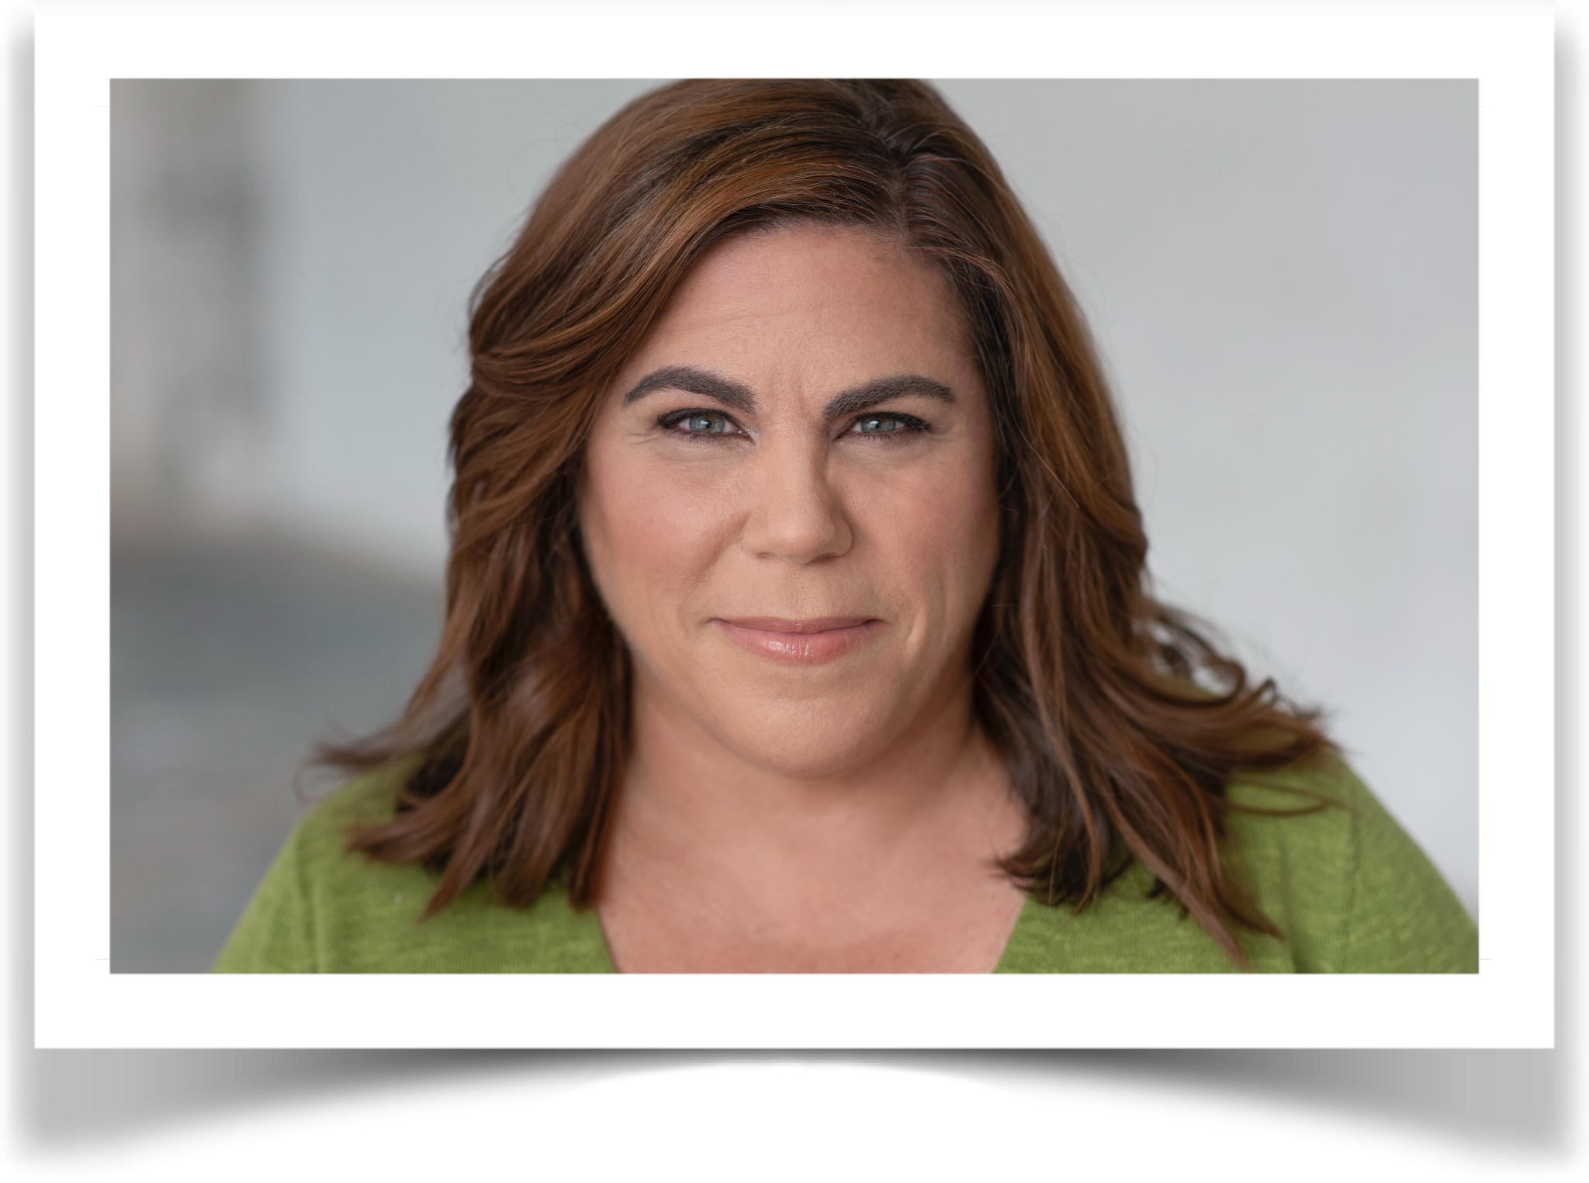Gretchen Reinhagen is an award-winning director, as well as a performer, best known to NYC audiences for her hit solo show, Special Kaye: A Tribute to the Incomparable Kaye Ballard. She's racked up multiple MAC and Bistro Awards, among others, most notably for Special Kaye, as well as for her debut album, Take it With Me, and her residency at the East Village supper club, Pangea, for which she won Major Recording and Major Female Vocalist awards. In addition to her work as an artist and director, she is also an actress and a voice teacher. www.gretchenreinhagen.com

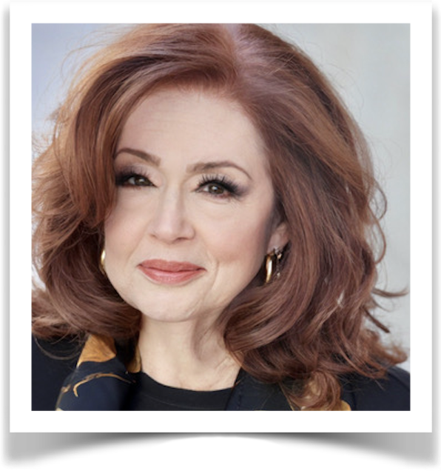Jane Scheckter is a two-time Bistro Award winner and seven-time MAC award nominee. This April, Jane was given a special Bistro award for “Outstanding Achievement and Sustained Cabaret Artistry.” Also this year, she was a MAC award nominee for her CD I’ll Take Romance and for the original song “Looking Back.” Stephen Holden of the New York Times wrote of her “bright clear voice with a brassy edge and a luscious, rounded vibrato, meticulous phrasing, a sultry lower register...and she swings!” Her fourth CD, Easy to Remember, with jazz all-stars Jay Leonhart, Bucky Pizzarelli, Harry Allen and Warren Vaché, was hailed as “Easily the finest songbook album of the year,” by Jazzwax. Her first CD had critics cheering her “Ella-styled artistry” (Downbeat) and welcoming “A brilliant star” (Daily News). She has played the major New York venues, including Birdland, the Metropolitan Room, the Iridium and Lincoln Center Jazz at Rose Hall. She sings regularly in jazz clubs in Paris and on the Cote d’Azur. Of her five CDs, two were recorded with Mike Renzi, her accompanist of 12 years, Jay Leonhart, and Grady Tate. Tedd Firth, her accompanist for the past 25 years, arranged and plays piano on her latest CD. Nicolas King duets with Jane on the Gershwins' "Isn't It a Pity.” Jane is a native of Springfield, MA, and a graduate of Pratt Institute. Before a career in singing, she appeared in The Proposition with Jane Curtin, and in a Los Angeles improv group for a year with Robin Williams. She sang backup on Barry Manilow's first album and recorded innumerable national jingles. Her web site is www.singjanesing.com.

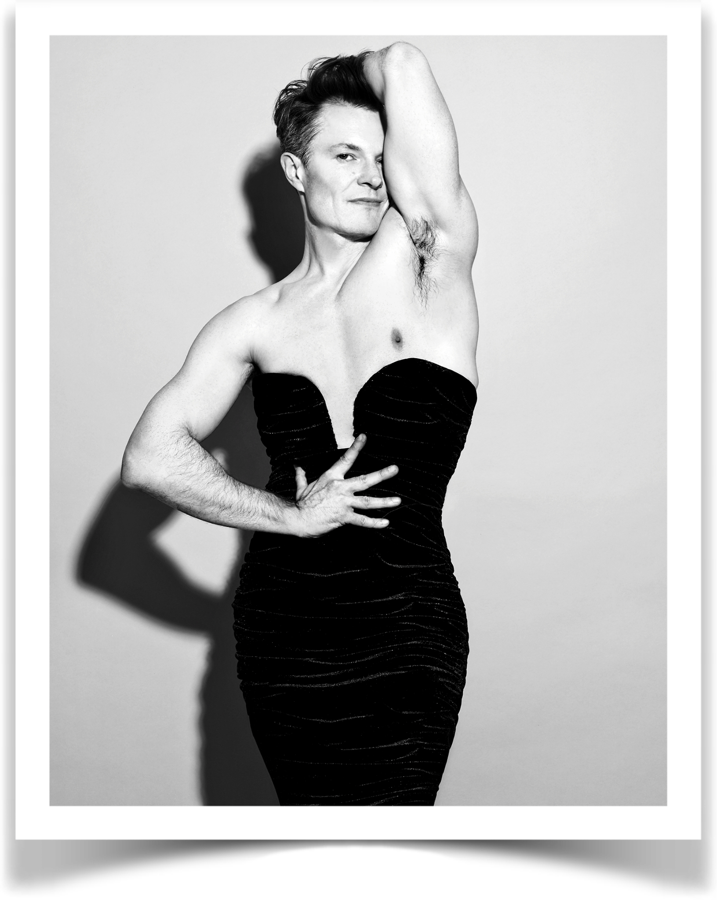Described by Broadway World as the “David Bowie of cabaret,” “slyly subversive” by The Wall Street Journal, and labeled the “male Marlene Dietrich” by the New York Times, Kim David Smith, hailing from Australia, is a Helpmann Award- and multi-MAC Award-nominated actor and cabaret artist. Smith’s debut live album Kim David Smith Live at Joe’s Pub received a 2022 Bistro Award, and is available to stream worldwide alongside his 2025 album, Mostly Marlene, which features duets with cabaret luminaries Charles Busch, Sidney Myer, Bright Light Bright Light, and Joey Arias.

Pianist/Music director/arranger/bandleader/singer-songwriter Tracy Stark is a 17-time MAC Award winner in the categories of Music Director, Piano Entertainer, and 3X Song of the Year. She is also a Bistro Award winner for Musical Direction, has won Cabaret Hotline’s Songwriter of the Year Award, and BroadwayWorld Award for Music Director, and most recently was awarded the 2025 MAC Award for Song of the Year, for her song “Better Place”. Tracy has worked with Sarah Dash (Labelle), Lesley Gore, Phoebe Snow, Karen Black (Academy Award nominee/Golden Globe winner), Nona Hendryx (Labelle), Randy Jones (Village People), Barb Jungr, Brenda Braxton (Tony nominee), Justin Sayre, Eric Millegan (Bones), Tonya Pinkins (Tony winner), Nathan Lee Graham (Grammy winnner), Alice Ripley (Tony winner) and hundreds of other rock, jazz, and broadway vocalists. She stays busy creating and music directing 75-100 different shows per year, in addition to her ongoing work as music director for the Eugene O’Neill Cabaret Conference for the past 13 years, and being the music director for the Provincetown Cabaret Festival. She has 3 albums of original music.

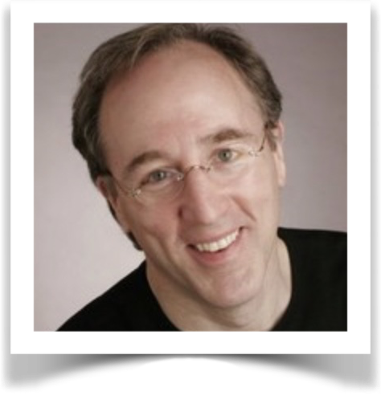Geoff Stoner is an actor, cabaret performer, and director. As an actor, Stoner most recently appeared as Tom in A Poster Of The Cosmos and as the Man in Breakfast At The Track, both produced by Deep Flight Productions as part of a trio of Lanford Wilson one-act plays presented at 59E59 and the 2025 Edinburgh Fringe Festival. He has appeared as the title character in a theatrical adaptation of Lois Lowry's novel The Giver, directed by Wynn Handman. Other New York productions include Tom in the New York premiere of Nightsweat by Robert Chesley, and Rupert in BoothTarkington’s The Trysting Place at the St. Peter's Theater. As a cabaret performer, Geoff's solo shows include A Short Visit Only, based on the life and songs of Noel Coward; You're The Top, featuring the songs of Cole Porter; and Words Wit Music, his slice-of-life account of growing up Episcopalian and randy in small-town Connecticut. As a director, he has worked on many solo cabaret shows and workshops around New York City. Stoner studied acting with Uta Hagen at HB Studio. He also studied improvisation at The Pit.

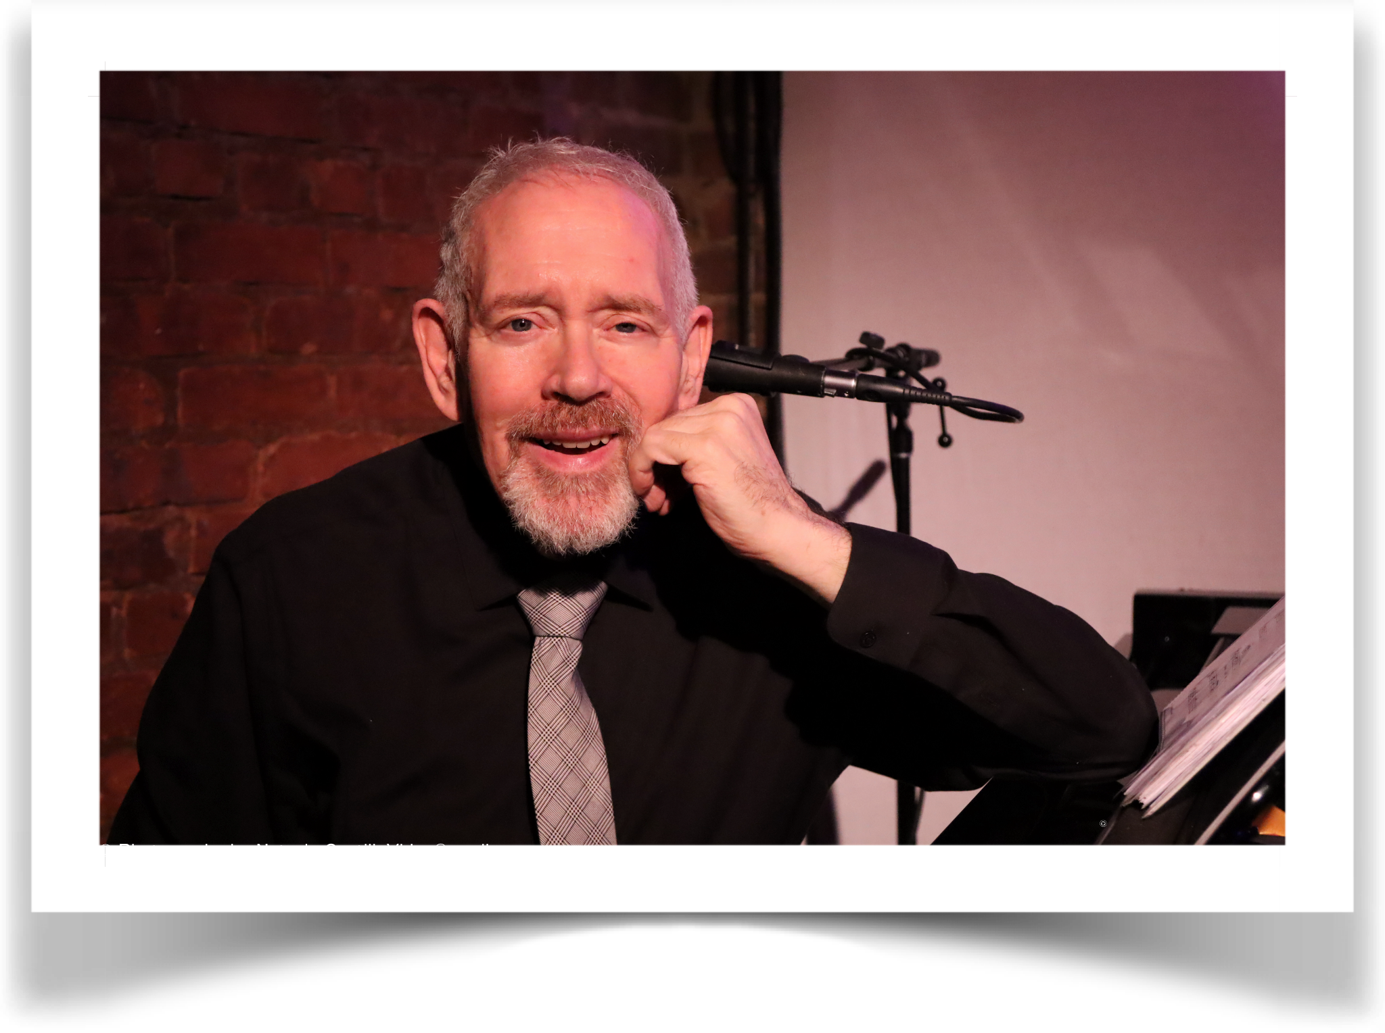Matthew Martin Ward (Musical Director/Arranger/Composer) is the winner of two 2024 MAC Awards: Best Debut (Male) for his critically acclaimed show What I Love, and Best Comedy/Novelty Song for “The Teachers I Remember” with a lyric by Peter Napolitano. Ward has spent his life acquiring a breadth and depth of knowledge and experience in all avenues of music. His career has centered on singers and musical theater in all its forms. Songwriter revues he has musical directed span Side by Side by Sondheim and Let's Call the Whole Thing Gershwin to evenings devoted to contemporary New York Songwriters such as Nicholas Levin, Tom Toce, Douglas Cohen, Stephen Cole; comedy revues include the legendary Forbidden Broadway and Whoop-Dee-Doo. Among the many solo acts he has played for, his collaboration with Christine Pedi has taken him from Birdland Jazz Club to South Africa; the shows he has created with partner Sally Darling have garnered glowing reviews. Special material written by Mr. Ward has been sung by Janice Hall, Adam Shapiro, Jay Rodgers, Julie Reyburn, Stearns Matthews, Tovah Feldshuh, Maureen Taylor, Erin Cronican and many more. As interested in how singing happens as in what is sung, he has taught vocal technique classes at Marymount Manhattan and Peridance, and accompanied master classes with Betty Buckley, Paul Bogaev, and Mary Setrakian. Onstage credits include Mark in Oil City Symphony, Alcindoro/Benoit and Colline in La Bohème, and Baritone in Berlin to Broadway, the music of Kurt Weill. He is the composer of After the Fair with Stephen Cole, and The Lady in Penthouse B with Peter Napolitano.

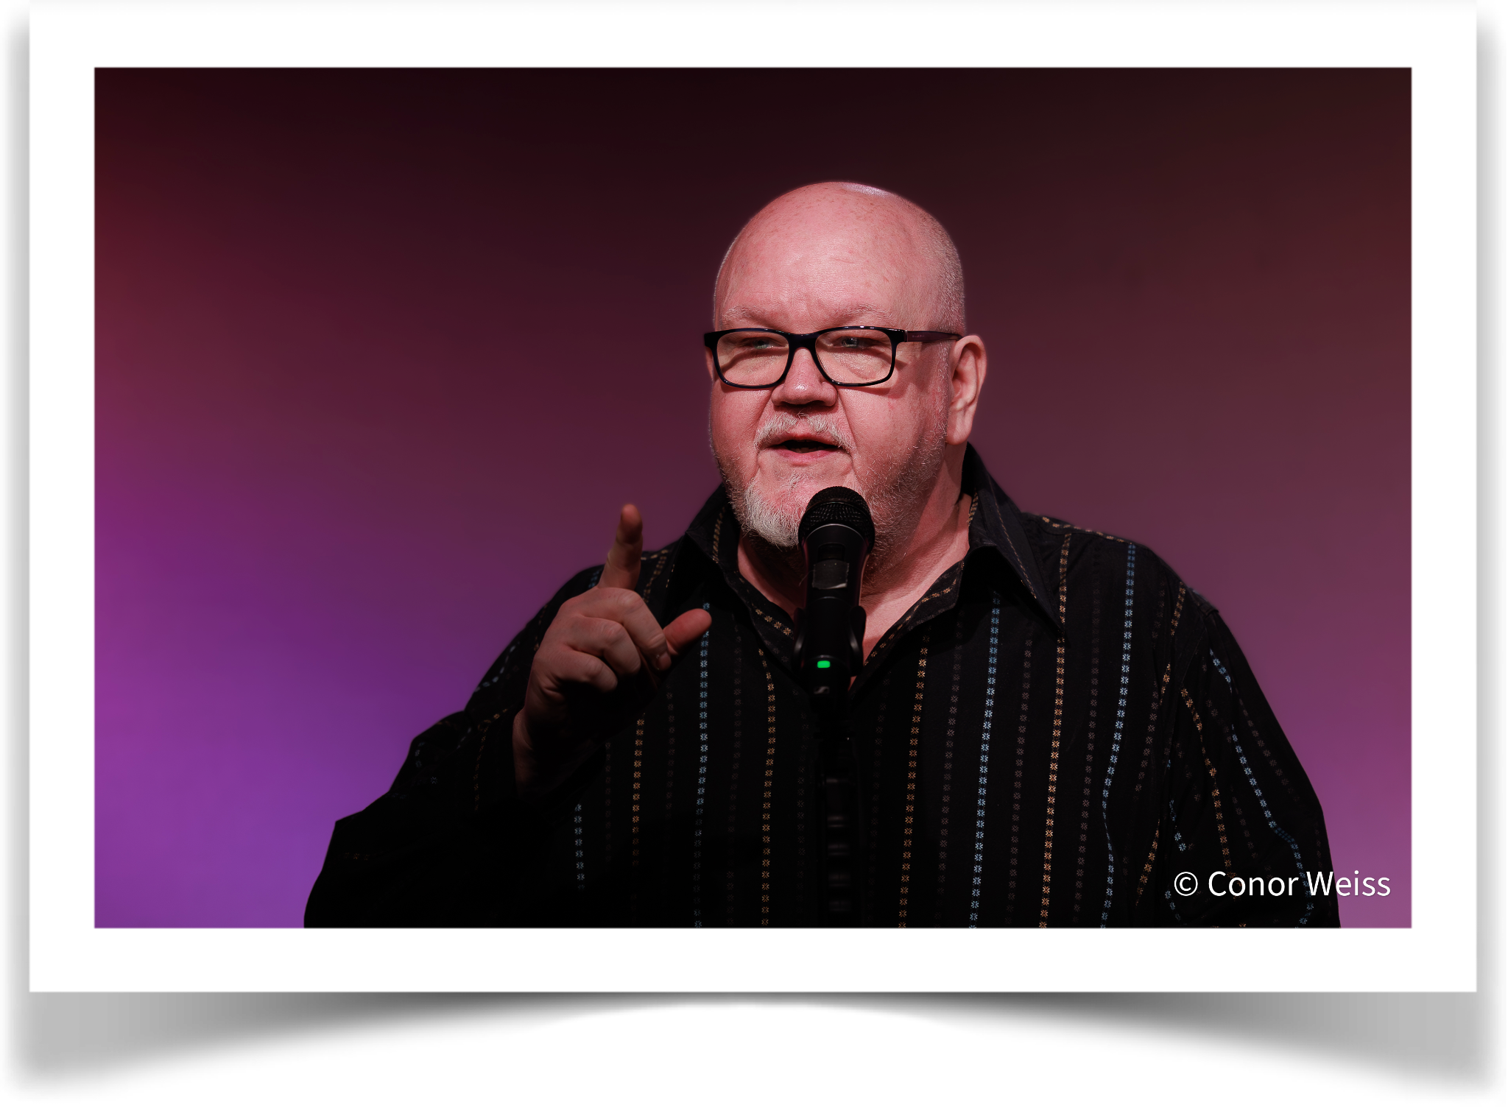Lennie Watts is a 22-time MAC, 5-time Backstage Bistro, 3-time Nightlife, and a 2014 Broadway World Award winner. He has been active in the New York cabaret scene for over 30 years. He has taught cabaret and performance workshops all over the country and in Italy. He has performed at Town Hall in several concerts, including "Broadway Unplugged" and "Broadway By The Year, 1949," and can be heard on the cast recordings of both shows. He has toured nationally and internationally with productions of The Music Man (Marcellus) and The Wizard Of Oz (Lion). His regional credits include productions of The Santaland Diaries (Crumpet), The Drowsy Chaperone (Man In Chair), Jesus Christ Superstar (Herod), and Guys and Dolls (Nicely). Lennie was recently named One of the 50 Most Influential People in Cabaret. The Village Voice calls him "A one man cabaret army!" He served as the President of MAC (Manhattan Association of Cabarets) for 15 years and now sits on MAC’s advisory board. He is the creator and Artistic Director of Singnasium, a nonprofit singing school in NYC. Singnasium.org

